DSP Playground

0.1.0 Release Notes

Circuit Schematic:

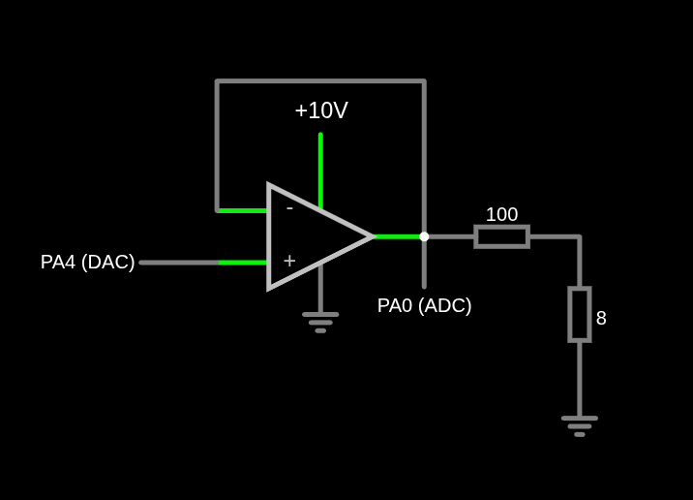
General explanation:
APB2 is TIM8’s and ADC1’s internal clock source. It was set to 90MHz.
The timer frequency is 112,640.8Hz. That’s an interrupt each 8.8777us. In each interrupt the DAC value (8 bits) is incremented by 1. It takes 256 interrupts until it overflows, when it’s reset to zero and completes a period. This takes ~2.273ms, almost exactly 440Hz, the desired tone. The waveform output through PA4 pin is the sawtooth from ~0V to ~3V (depending on DAC’s max voltage).
The ADC reads the Op. Amp. Output voltage through PA0. According to the datasheet, C_{ADC}=7pF and R_{ADC}=6kΩ. Considering the signal output impedance as null that’s a 252ns charging time. With an ADC clock of 22.5MHz, that’s 5.67 cycles. That’s why sampling time is set to 15 cycles. It’s also set to 8 bits because that’s the DAC’s resolution. The total conversion time is (11+15)/22.5MHz = 1.16us.
The ADC starts the conversion when TIM8’s counter is about half way there to being reloaded, at counter = 8. After the conversion (1.16us later), the counter is still between 10 and 11, still quite far from being reloaded (interrupt trigger – DAC update moment). This way it is ensured that the ADC always reads the voltage between DAC updates.

Result:
I have no oscilloscope at home so I can’t really see if it’s working perfectly. I tried displaying the ADC value in a chart using SWV (couldn’t manage to make it work) and CubeMonitor (sample rate too low). None worked. However, the timbre looks similar to this sawtooth sound example. Using the Tuner app on my phone, I got:
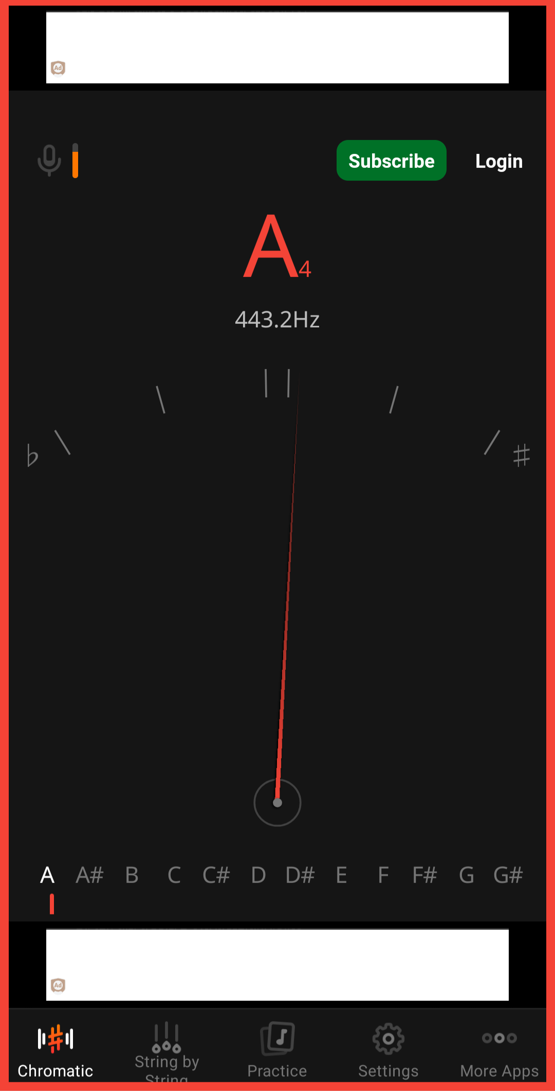

It was designed to be better……… But that’s what I’m going to work with.

